**Week 2 Assignment**

Adam Chambers

The University of Arizona Global Campus

CST499: Computer Software Technology Capstone

Joseph Rangitsch

4/22/2024

Software testing is an indispensable process in the development of reliable and functional software products. It encompasses several stages, each designed to ensure different aspects of software quality from the smallest components to the final product ready for market release. This essay explores the four main levels of software testing—Component Testing, Integration Testing, System Testing, and Acceptance Testing—highlighting the significance of each stage with relevant academic insights and discussing the tools and techniques used in each.

Component testing, also known as unit testing, is the first level of defense in software quality assurance. It focuses on the smallest units of software, such as functions or methods within modules, ensuring that each unit performs as expected independently of others. Wu, Pan, and Chen (2001) discuss component testing in their study, emphasizing the importance of a structured approach. They introduce a test model using a component interaction graph (CIG) that illustrates interactions and dependencies among components. This model helps in optimizing test coverage by balancing budget, schedule, and quality requirements, essential for effective software development. Tools like JUnit and NUnit facilitate component testing by automating the execution of test cases and comparison of expected and actual outcomes, thereby increasing efficiency and accuracy.

After component testing, the next level is integration testing. This stage evaluates the interactions between integrated units or components to detect interface defects. Integration testing is crucial because it addresses issues that arise when units are combined to form larger functional segments. Jin and Offutt (1995) provide an extensive overview of integration testing techniques, notably the coupling-based testing approach. This technique utilizes the dependencies between software components to guide the testing process, proving effective in identifying more faults with fewer test cases than other methods. Tools like TestNG and Postman support integration testing by providing frameworks that allow testers to define test flows that cover multiple components and their interactions.

Moving beyond integration testing, system testing evaluates the system as a whole against the specified requirements. It is a comprehensive form of testing that covers both functional and non-functional requirements. Briand and Labiche (2001) describe a UML-based approach to system testing, which derives test requirements from UML artifacts such as use cases and class diagrams. This method ensures that the system testing is thorough and aligns with the system's design and user expectations. Tools like Selenium and QTP (QuickTest Professional) are widely used in system testing for automating browser actions and user interactions to ensure the system operates as intended across different environments and conditions.

The final level of testing before a product is released is acceptance testing. This stage involves stakeholders and is intended to confirm that the software meets all user acceptance criteria. Leung and Wong (1997) examine the user acceptance test (UAT), highlighting its critical role as the final validation step before operational deployment. They introduce various approaches to UAT, including behavior-based and operation-based strategies, ensuring that the software meets the quality standards required by the end-users. Tools like Cucumber and FitNesse are used in acceptance testing to facilitate communication between business analysts, developers, and testers, and to automate the execution of tests written in business-readable language.

In conclusion, the structured approach to software testing through these four levels ensures that each phase of software development is rigorously verified, leading to a high-quality product that meets both the technical specifications and the user requirements. Each stage builds upon the previous, culminating in acceptance testing that confirms the software's readiness for the market, thus safeguarding the product's reliability and the end-users' satisfaction. The application of specialized tools and techniques at each stage enhances the effectiveness and efficiency of testing, thereby optimizing the development process and product quality.

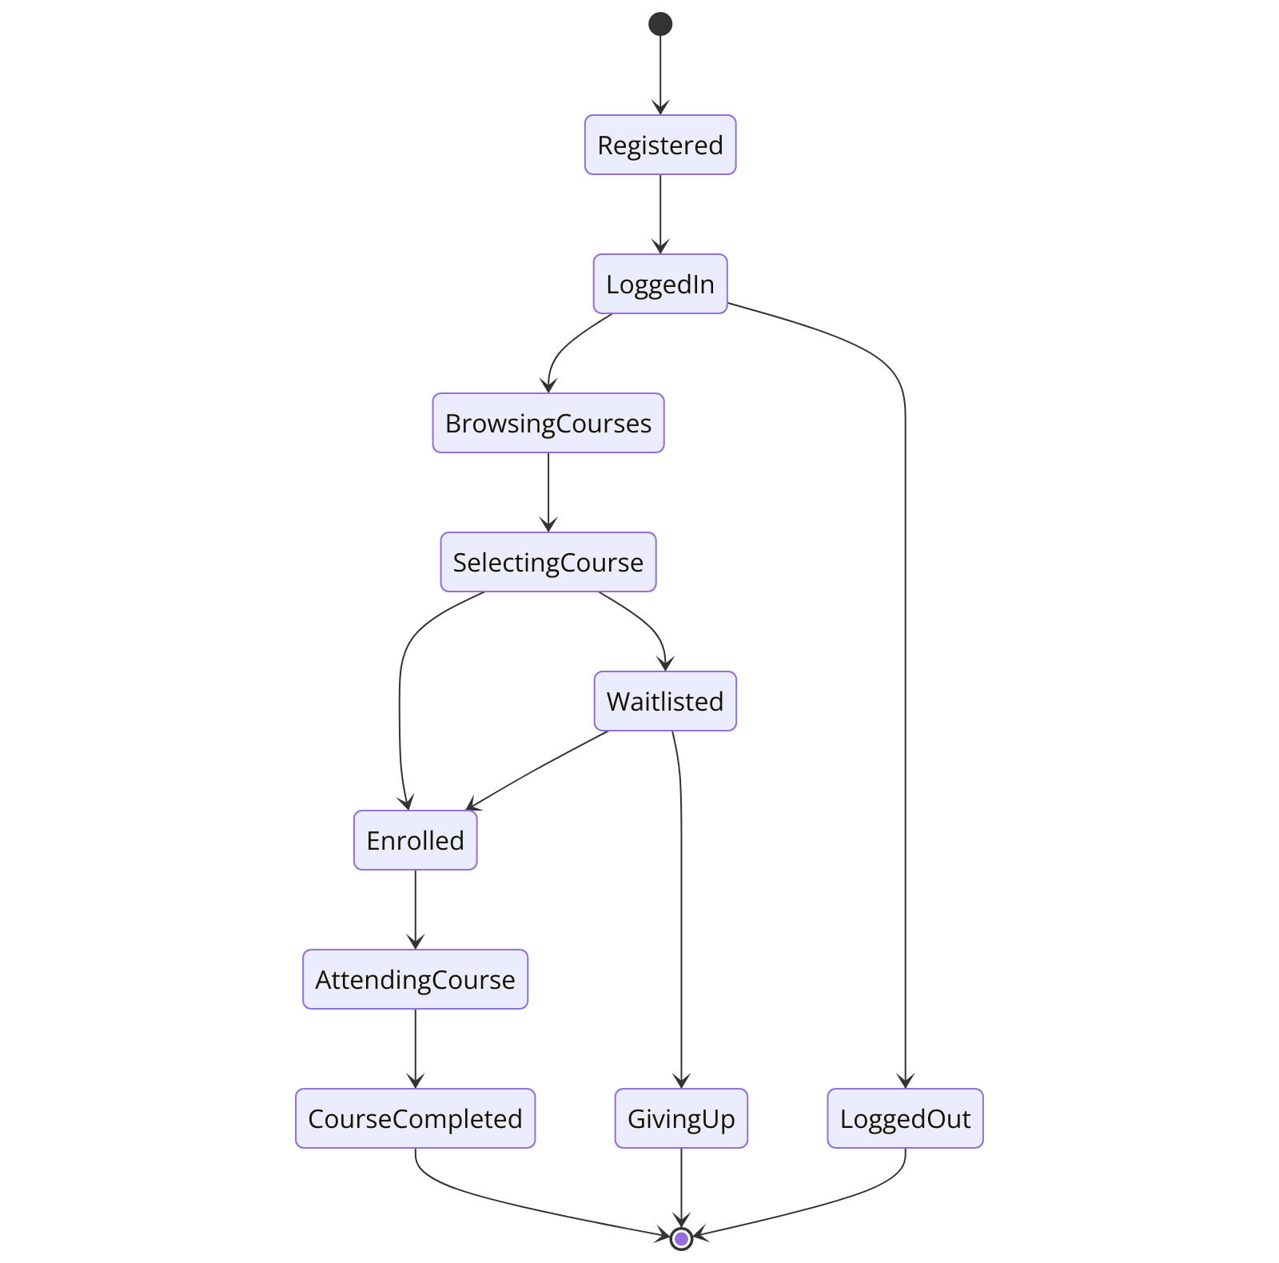

Figure 1 – State Diagram

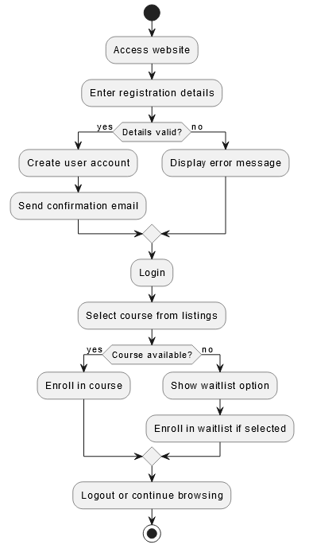

Figure 2 – Activity Diagram

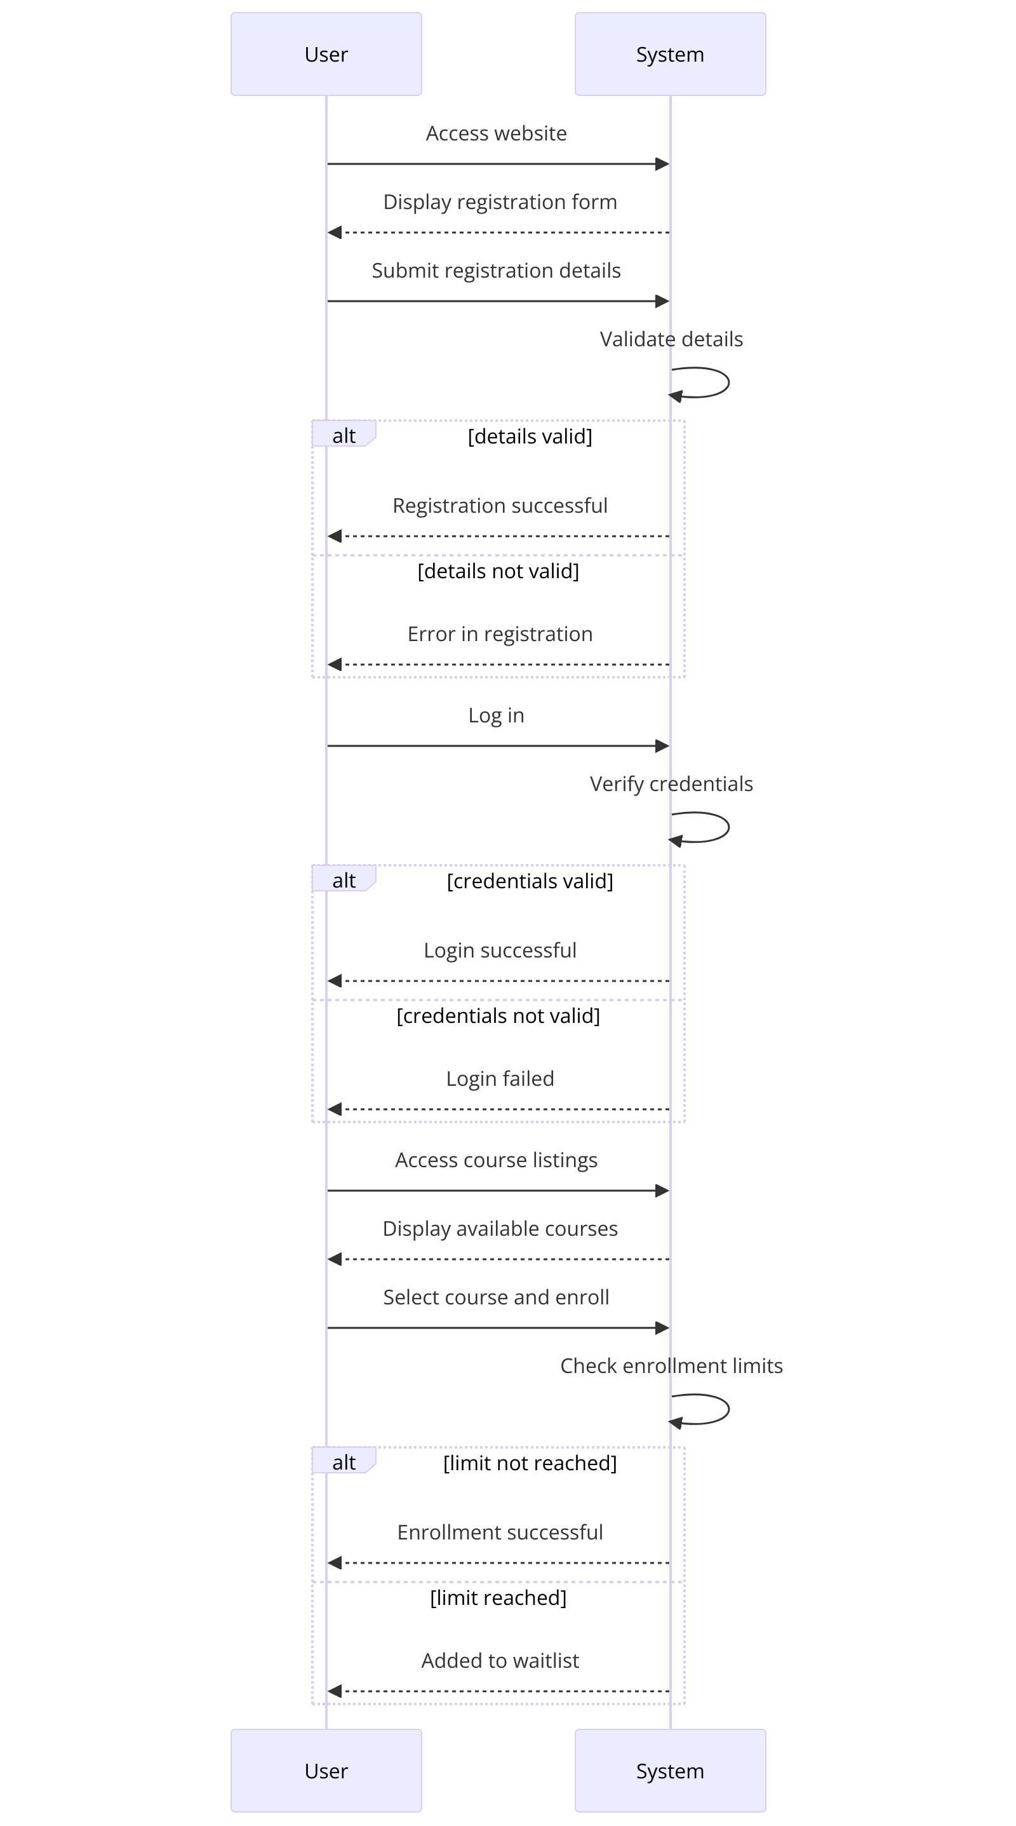

Figure 3 – Sequence Diagram

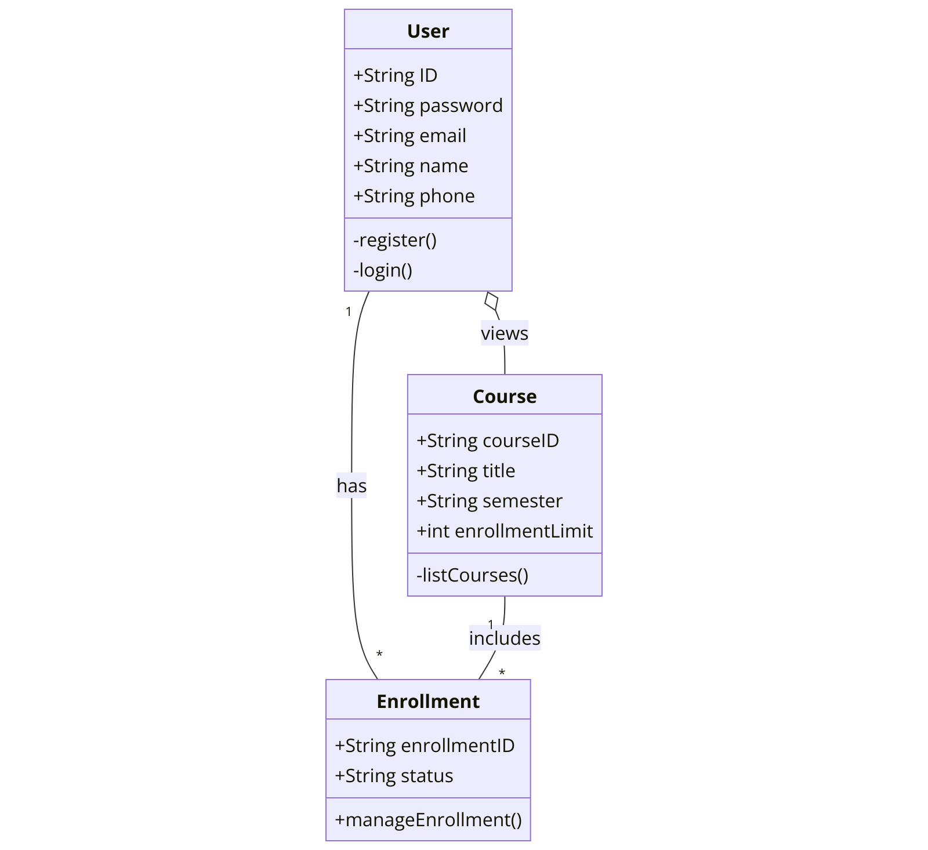

Figure 4 – Class Diagram

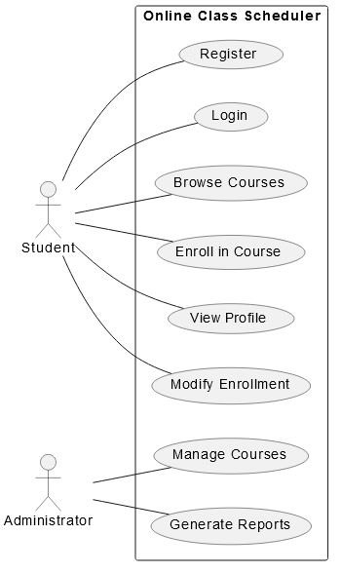

Figure 5 – Use Case Diagram

**References**

Briand, L., & Labiche, Y. (2001). A UML-based approach to system testing. Software and

Systems Modeling, 1, 10-42.

Jin, Z., & Offutt, A. (1995). Integration testing based on software couplings. COMPASS '95

Proceedings of the Tenth Annual Conference on Computer Assurance Systems Integrity,

Software Safety and Process Security'.

Leung, H., & Wong, P. W. L. (1997). A study of user acceptance tests. Software Quality Journal,

6, 137-149.

Wu, Y., Pan, D., & Chen, M.-H. (2001). Techniques for testing component-based software.

Proceedings Seventh IEEE International Conference on Engineering of Complex

Computer Systems.